Syeda Reeha Quasar

14114802719

4C7

Aim

Create a base class basic_info with data members name, roll no, sex and two member functions getdata and display. Derive a class physical_fit from basic_info which has data members height and weight and member functions getdata and display. Display all the information using object of derived class.

Experiment - 16

Object Oriented Programming Lab

# **EXPERIMENT – 16**

## **Aim:**

Create a base class basic_info with data members name, roll no, sex and two member functions getdata and display. Derive a class physical_fit from basic_info which has data members height and weight and member functions getdata and display. Display all the information using object of derived class.

## **Source Code:**

#include <iostream>

#include<string>

using namespace std;

class basic_info

{

    string name;

    int rno;

    char sex;

public:

    void getdata();

    void putdata();

};

void basic_info::getdata()

{

    cout << "Enter name: ";

    cin >> name;

    cout << "Enter rollno: ";

    cin >> rno;

    cout << "Enter sex: ";

    cin >> sex;

}

void basic_info::putdata()

{

    cout << "\n\n\n";

    cout << "Name     : " << name << endl;

    cout << "Roll No. : " << rno << endl;

    cout << "Sex      : " << sex << endl;

}

class phy_fit : public basic_info

{

    float ht;

    float wt;

public:

    void input()

    {

        getdata();

        cout << "Enter height (in cms): ";

        cin >> ht;

        cout << "\nEnter weight (in kg): ";

        cin >> wt;

    }

    void display()

    {

        putdata();

        cout << "\nHeight  : " << ht;

        cout << "\nWeight  : " << wt;

    }

};

main()

{

    phy_fit obj;

    obj.input();

    obj.display();

    return 0;

}

## **Output:**

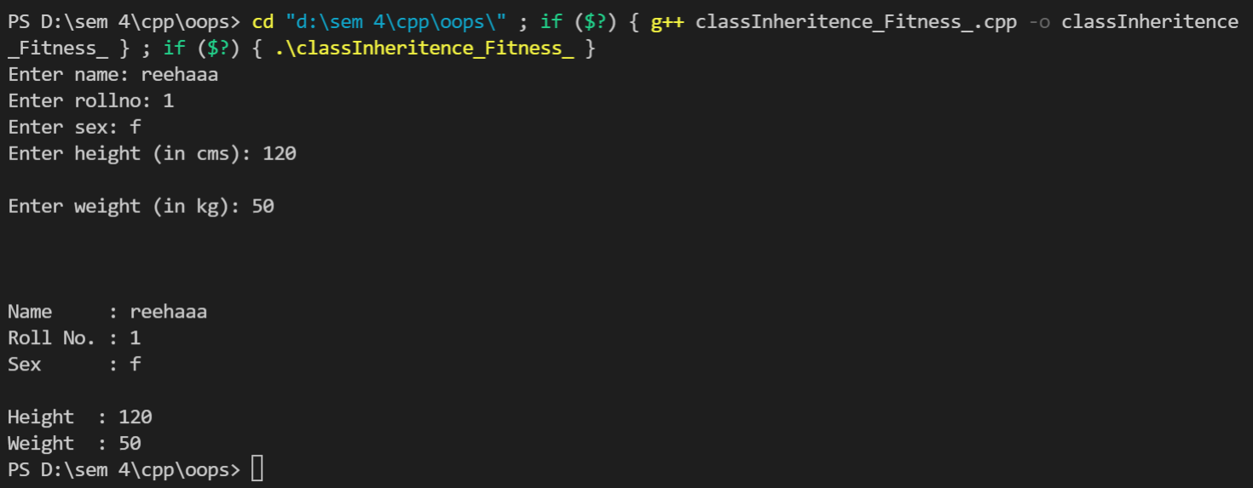

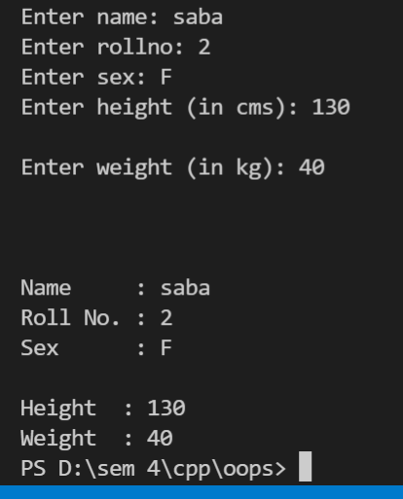

# **Viva Questions**

#### Q1) What is inheritance?

Ans.

Inheritance is one of the feature of Object Oriented Programming System(OOPs), it allows the child class to acquire the properties (the data members) and functionality (the member functions) of parent class.

*Q2) What is child class?*

*Ans.*

*A class that inherits another class is known as child class, it is also known as derived class or subclass.*

*Q3) What is parent class?*

*Ans.*

*The class that is being inherited by other class is known as parent class, super class or base class.*

### Q4) What are the advantages of using inheritance in C++ Programming?

Ans.

The main advantages of inheritance are code reusability and readability. When child class inherits the properties and functionality of parent class, we need not to write the same code again in child class. This makes it easier to reuse the code, makes us write the less code and the code becomes much more readable.